SMART WATER FOUNTAIN USING IOT

TEAM MEMBER

111421106045 : SOMU VENKATESWARLU

PHASE 4 : DEVELOPMENT PART-2

Abstract :

Smart water fountains are innovative and technologically advanced water dispensing systems that incorporate various sensors, connectivity, and automation to improve water accessibility, conservation, and user experience. These fountains leverage IoT (Internet of Things) technology to monitor water quality, track consumption, and provide real-time data for both users and maintenance teams. Additionally, they often include features such as touchless operation, water purification, and customizable settings. Smart water fountains not only enhance the efficiency and hygiene of public water sources but also contribute to sustainability efforts by reducing water wastage and promoting responsible water usage. This abstract explores the concept and potential benefits of smart water fountains in the context of modern urban environments.

SYSTEM DESIGN AND ARCHITECHTURE

Raspberry Pi Pico: This will be the brain of your project

Water pump : To control the flow of water

Sensors: you can use sensors like ultransonic distance sensors to detect when a user approaches the fountain and water level sensors to monitor the water level

Display (optional): you can add an LCD or LED display to show information like water level, temperature, or a welcoming message.

Power supply: Ensure you have an appropriate power supply for your components

Relay or Transistors: To control the water pump based on sensor inputs.

MOBILE APP DEVELOPMENT:

You can create a mobile app for both android and ios platforms. You have several options for app development , including:

* Native Development : use the platform specific languages and development environments (swift / objectives-c for ios ,java/kotlin for android).
* Cross platform development: use frameworks like react native ,flutter, or Xamarin to develop a single codebase that works on both ios and android

CREATE USER INTERFACE:

Design the mobile app user interface to control your smart water fountain . this can include buttons or silders to start /stop the fountain , adjust water flow, and monitor water level .

MOBLIE APP -SERVER COMMUNICATIONS:

You need a way for your mobile app to communicate with your raspberry pi,which acts as the server for your iot project

* This can be achieved through a few different methods:
* HTTP REQUESTS: you can set up a restful api on your raspberry pi,and the mobile app sends http requests to control the fountain
* MQTT: implement MQTT client functionality in your mobile app to send and receive messages from your raspberry pi
* WEB SOCKET : use web sockets for real time communication between the mobile app the raspberry pi.

SECURE COMMUNICATION :

Implement secure communication between the mobile app and your raspberry pi.this typically includes using encryption , authentication ,and authorization to protect the data and control functions.

MOBLIE APP DEVELOPMENT:

Write the code for your mobile app, including the logic for sending commands to the raspberry pi,receiving updates , and displaying the fountains status .ensure that the app can handle different states , such as starting ,stopping ,and error handling.

TEST YOUR APP:

Thoroghly test your mobile app, both locally and with the raspberry pi,ensure that it can connect to your raspberry pi and control the smart water fountain as intended.

DEPLOY THE MOBLIE APP:

Publish your mobile app on the respective app stores(google play store for android and apple app store for ios ) . this will make it available to users for download.

USER ACCOUNT AND AUTHENTICATION:

If your want to restrict access or have user specific settings ,you may need to implement user accounts and authentication in your mobile app.

USER DOCUMENTATION:

Provide clear instruction or user documentation on how to download install , and use the mobile app in conjuction with your smart water fountain.

Once you’ve completed these steps ,users can download the app , connect it to your raspberry pi,and control the water fountain remotely .make sure to maintain and update your app and iot system as needed to provide a seamless user experience.

MOBILE APP PYTHON CODE :

import requests

# Define the Raspberry Pi's IP address

raspberry_pi_ip = 'your_pi_ip_address'

# Start the water fountain

response = requests.post(f'http://{raspberry_pi_ip}:5000/start')

if response.status_code == 200:

print('Fountain started')

# Stop the water fountain

response = requests.post(f'http://{raspberry_pi_ip}:5000/stop')

if response.status_code == 200:

print('Fountain stopped')

# Get water level

response = requests.get(f'http://{raspberry_pi_ip}:5000/water-level')

if response.status_code == 200:

water_level = response.json()['water_level']

print(f'Water level: {water_level}’)

WEB DEVELOPMENT TECHNOLOGIES USING JAVASCRIPT CODE:

<html>

<head>

<title>Smart Water Fountain</title>

<style>

/* CSS for styling the fountain (same as before) */

/* ... */

.water-flow.stopped {

animation-play-state: paused;

}

</style>

</head>

<body>

<h1>Smart Water Fountain</h1>

<div class="fountain">

<div class="water-flow"></div>

</div>

<button id="startButton">Start Fountain</button>

<button id="stopButton">Stop Fountain</button>

<input type="range" id="flowRate" min="1" max="10" value="5">

<p>Flow Rate: <span id="flowRateValue">5</span></p>

<script>

const waterFlow = document.querySelector(".water-flow");

const startButton = document.getElementById("startButton");

const stopButton = document.getElementById("stopButton");

const flowRateSlider = document.getElementById("flowRate");

const flowRateValue = document.getElementById("flowRateValue");

let currentFlowRate = 5; // Default flow rate

startButton.addEventListener("click", () => {

waterFlow.style.animationPlayState = "running";

});

stopButton.addEventListener("click", () => {

waterFlow.style.animationPlayState = "paused";

});

flowRateSlider.addEventListener("input", () => {

currentFlowRate = flowRateSlider.value;

flowRateValue.textContent = currentFlowRate;

const animationDuration = 10 / currentFlowRate; // Inverse of flow rate

waterFlow.style.animationDuration = `${animationDuration}s`;

});

</script>

</body>

</html>

OUTPUT :

The coding is in the language of java script

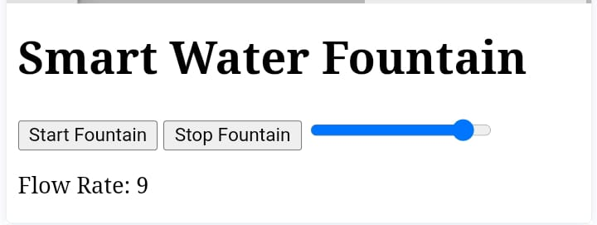

The code is executed successfully .development of the mobile app and web development technologies is successfully implemented.